ViewData in ASP.NET Core MVC Application
in ASP.NET Core MVC application, we can pass the data from a controller action method to a view in many different ways such as by using ViewBag, ViewData, and using a strongly typed model.

What is ViewData in ASP.NET Core MVC Application?
The ViewData in ASP.NET Core MVC is a dictionary of weakly typed objects which is derived from the ViewDataDictionary class.
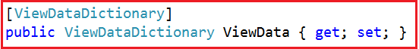
Now, look at the definition of ViewDataDictionary as shown below.
As you can see in the above image, the ViewDataDictionary implements ICollection, IEnumerable, and IDictionary interfaces where it will store the data in the form of key-value pairs. Here, the key is of type String and the value is of type object i.e. we can store any type of data.
What is the use of ViewData?
- ViewData is used to pass the data from the controller action method to a view and we can display this data on the view.
- The ViewData is work on the principle of Key-value pairs. This type of binding is known as loosely binding.
- We can pass any type of data in ViewData like normal integer, string, even though you can pass objects.
- ViewData uses the ViewDataDictionary type.
How to use ViewData?
First, we need to create a new key in ViewData and then assign some data to it. The key should be in string format and you can give any name to it and then you can assign any data to this key.
ViewData[“KeyName”] = “Some Data”;
Since ViewData is a server-side code, hence to use it on view, we need to use the razor syntax i.e. @
@ViewData[“KeyName”]
You can access the string data from the ViewData dictionary without casting the data to string type. But if you are accessing data other than the string type then you need to explicitly cast the data to the type you are expecting.
Example: Accessing string data
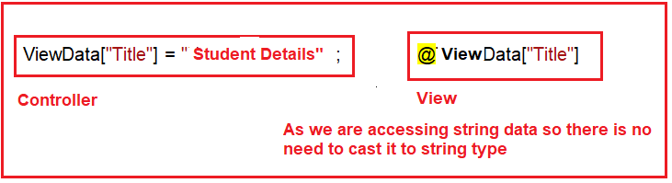
Example: Accessing Student Data:
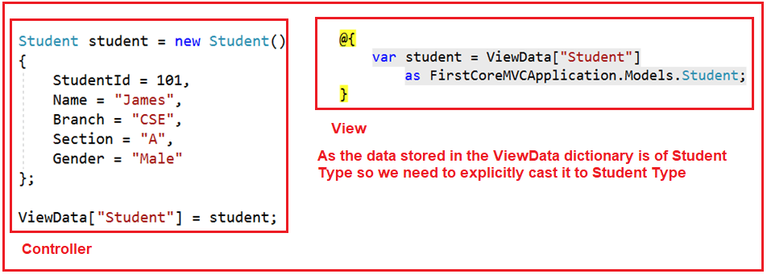
Note: We can use n number of ViewData on a single view. ViewData can also be used to pass data from view to its layout view.
ViewData Example in ASP.NET Core MVC Application:
Let us see an example to understand how to use ViewData to pass data from a controller action method to a view. In our example, we want to pass three pieces of information to the view from the controller action method. One is the Title of the page, the second is the Header of the Page and the third one is the Student data that we want to display on the page.

The ViewData is dynamically resolved at runtime, as a result, it does not provide any compiles time error checking as well as we do not get any intelligence. For example, if we miss-spell the key names then we wouldn’t get any compile-time error. We get to know about the error only at runtime.
The ViewData only transfers the data from the controller action method to a view, but not vice-versa. That means it is valid only during the current request.
Example of ViewData
In Model create student.cs paste this
public class Student
{

public string StudentId { get; set; }
public string Name { get; set; }
public string Age { get; set; }
public string Branch { get; set; }
}

StudentController
public ViewResult StuDetail()
{

ViewData["Title"] = "Student INformation";
ViewData["Header"] = " Student Details";
//If you wants to print multiple student records
IList<Student> StudentList = new List<Student>();

StudentList.Add(new Student() { StudentId = "101", Name = "Amit", Age = "12", Branch = "CS" });
StudentList.Add(new Student() { StudentId = "1012", Name = "Ankit", Age = "22", Branch = "CS" });

// If you wants to print single student record

Student st = new Student()
{
StudentId = "s101",
Name = "Aarav",
Age = "5",
Branch = "cse"

};
ViewData["Student"] = st;
ViewData["Student1"] = StudentList;

return View();
}
View–StuDetail.cshtml
@{

Layout = null;
}

<html>
<head>
<title>

@ViewData["Title"]
</title>

</head>

// Single record printing
<body>
<h1>

@ViewData["Header"]

</h1>

@{

var student = ViewData["Student"] as WebApplication58.Models.Student;

}

<div>

StudentID : @student.StudentId
</div>

<div>

StudentID : @student.Name
</div>

<div>

StudentID : @student.Age
</div>

<div>

StudentID : @student.Branch
</div>
// when multiple records printing
<ul>

@foreach (var std in ViewData["student1"] as IList<Student>)
{

<li>
@std.StudentId
</li>

<li>
@std.Name
</li>
<li>
@std.Age
</li>
<li>
@std.Branch
</li>

}
</ul>

</body>

</html>

ViewBag in ASP.NET Core MVC
The ViewBag in ASP.NET Core MVC is one of the mechanisms to pass the data from a controller action method to a view. If you go the Controller base class, then you will find the following signature of the ViewBag property.
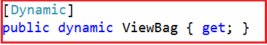
So the ViewBag is a dynamic property of the Controller base class. The dynamic type is introduced in C# 4.0. It is very much similar to the var keyword that means we can store any type of value in it but the type will be decided at run time rather than compile-time.
The ViewBag transfers the data from the controller action method to a view only, the reverse is not possible.
How to Pass and Retrieve data From ViewBag in ASP.NET Core MVC?
The point that you need to keep in mind is, ViewBag is operating on the dynamic data type. So we don’t require typecasting while accessing the data from a ViewBag. It does not matter whether the data that we are accessing is of type string or any complex type.
ViewBag in ASP.NET Core MVC with String Type:
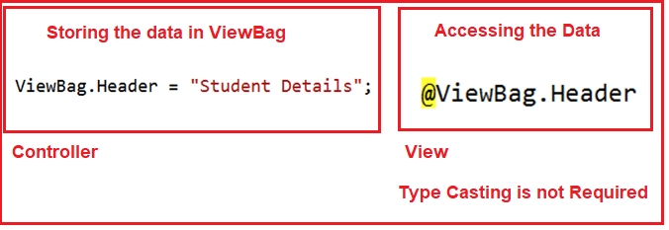
ViewBag in ASP.NET Core MVC with Complex Type:
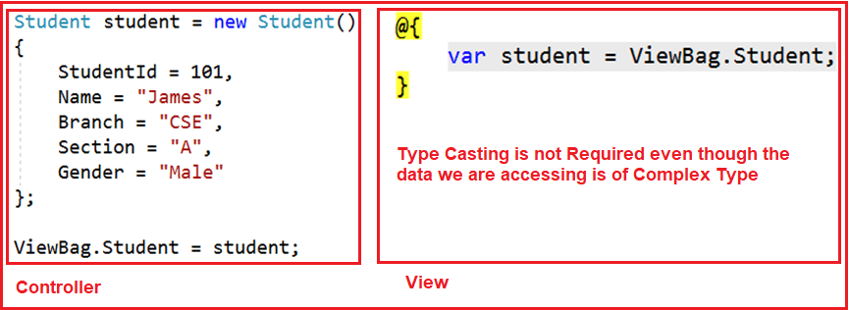

Difference between ViewData and ViewBag in ASP.NET Core MVC
- In ASP.NET Core MVC, we can use both ViewData and ViewBag to pass the data from a Controller action method to a View.
- The ViewData is a weakly typed dictionary object whereas the ViewBag is a dynamic property. Both ViewData and ViewBag are used to create a loosely typed view in MVC.
- In ViewData, we use string keys to store and retrieve the data from the ViewData dictionary whereas in ViewBag we use the dynamic properties to store and retrieve data.
- Both the ViewData keys and ViewBag dynamic properties are resolved only at runtime. As a result, both do not provide compile-time error checking and because of this, we will not get intelligence support.
- So if we misspell the key names or dynamic property names then we will not get any compile-time error rather we came to know about the error only at run time. This is the reason why we rarely used ViewBag and ViewData in our application.

